BVU/SBU guidelines for BCG usage during the period of BCG shortage:

1. General rules:
- In order to help reduce the number of BCG doses per patient, it is vital to include as many patients as possible into clinical trials. A number of clinical trials for (very) high risk patients with non-muscle-invasive bladder cancer (NMIBC) are open at several Belgian institutions which for example involve immunotherapy. Consider to include your patient in a running clinical trial as full dose is often provided within the trial. Information around running trials in NMIBC are available on the BVU/SBU websites. Further information on can be obtained by contacting the Study Coordinator

b. When BCG is considered for a patient, an induction course and 1 year of maintenance should be given to each patient. In order to secure the completion of maintenance BCG treatment, it is therefore advisable that urologists do not start a patient on BCG if it is unsure whether that patient will finish both induction and maintenance treatment, unless BCG supply for that patient can be guaranteed by MSD Belgium. MSD Belgium has contacted the hospital pharmacies of all Belgian centers and will calculate, based on the average use of BCG per center, the exact number of BCG vials that each center will receive per month.

2. High-risk NMIBC
a. Lower risk for progression:
T1 or Tis or G3/HG or multiple AND recurrent AND > 3 cm TaG1-2/LG
- New patient: Induction BCG (6x weekly at 1/3 reduced dose) – REBIOPSY – Maintenance BCG (3x 3-monthly 1/3 reduced dose) – STOP maintenance after 1 year.
- New patient (ALTERNATIVE): Induction EPIRUBICIN (8x weekly) – REBIOPSY – Maintenance EPIRUBICINE (1x monthly from month 3 until month 12)
- Patient currently under maintenance BCG: STOP maintenance after 1 year

b. Highest risk for progression:
T1G3/HG + CIS, T1G3/HG + CIS in prostatic urethra, multiple T1G3/HG, T1G3/HG > 3 cm, LVI or some variants of urothelial carcinoma
- Inform patient of risk for progression and discuss possibility of early radical cystectomy.
- New patient: Induction BCG (6x weekly 1/3 reduced dose) – REBIOPSY – Maintenance BCG (3x 3-monthly 1/3 reduced dose) – STOP maintenance after 1 year
- New patient (preferred ALTERNATIVE): EPIRUBICIN instillations by Device-Assisted Therapy (DAT) / Thermotherapy
- New patient (ALTERNATIVE): Induction Gemcitabine instillations (6x weekly à 2000 mg/50ml solution)
- Patient currently under maintenance BCG: STOP maintenance after 1 year

c. BCG refractory NMIBC at rebiopsy post-induction BCG:
  - ≥T2 in REBIOPSY: cystectomy (assess patient for neo-adjuvant chemotherapy)
  - T1, high grade or CIS in REBIOPSY: consider early cystectomy
  - T1, high grade or CIS in REBIOPSY (ALTERNATIVE): EPIRUBICIN instillations by Device-Assisted T herapy (DAT) / Thermotherapy
  - Ta, low grade in REBIOPSY: TURBT

3. Intermediate-risk NMIBC
a. Primary or recurrent tumor without previous chemotherapy:
      - Induction EPIRUBICIN (8x weekly) – REBIOPSY – Maintenance EPIRUBICIN (1x monthly from month 3 until month 12)
      - Patient currently under maintenance BCG: SWITCH to EPIRUBICIN maintenance until 1 year from BCG induction.

b. Recurrent tumor with previous chemotherapy:
- New patient: Induction BCG (6x weekly at 1/3 reduced dose) – REBIOPSY – Maintenance BCG (3x 3-monthly 1/3 reduced dose) – STOP maintenance after 1 year.
- New patient (ALTERNATIVE): Induction EPIRUBICIN (8x weekly) – REBIOPSY – Maintenance EPIRUBICIN (1x monthly from month 3 until month 12)
- Patient currently under maintenance BCG: STOP maintenance after 1 year

Optional additional general rule:
c. It is advisable that pathologist also report the WHO 1973 grading system (G1-2-3) in their report for patients with T1 disease that are considered for BCG therapy. Recently, it has been shown that the WHO 2004 grading system was not prognostic in patients with T1 disease. Usage of the WHO 1973 could potentially reduce the use of BCG in patients with HG disease (WHO 2004) which would be classified as G2 (WHO 1973).

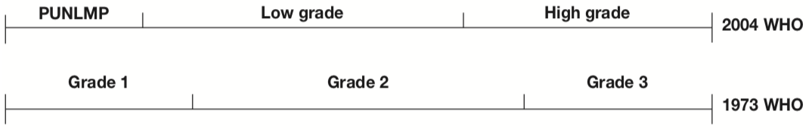
﻿
Ref
van de Putte EEF, Bosschieter J, van der Kwast TH, Bertz S, Denzinger S, Manach Q, et al. The World Health Organization 1973 classification system for grade is an important prognosticator in T1 non-muscle-invasive bladder cancer. BJU Int 2018;122:978–85. doi:10.1111/bju.14238.

